NAME: | PARVENDHAN C
ROLL NO: | 241801197
DEPT: | AI&DS

- The HR department needs a query that prompts the user for an employee last name. The query then displays the last name and hire date of any employee in the same department as the employee whose name they supply (excluding that employee). For example, if the user enters Zlotkey, find all employees who work with Zlotkey (excluding Zlotkey).
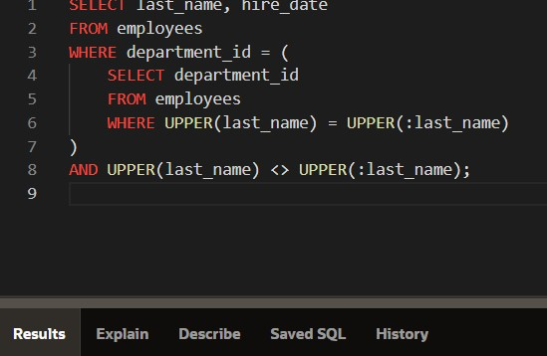

- Create a report that displays the employee number, last name, and salary of all employees who earn more than the average salary. Sort the results in order of ascending salary.
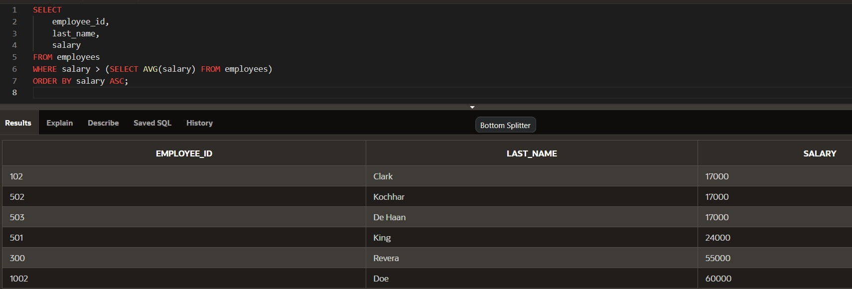

- Write a query that displays the employee number and last name of all employees who work
in a department with any employee whose last name contains a u.
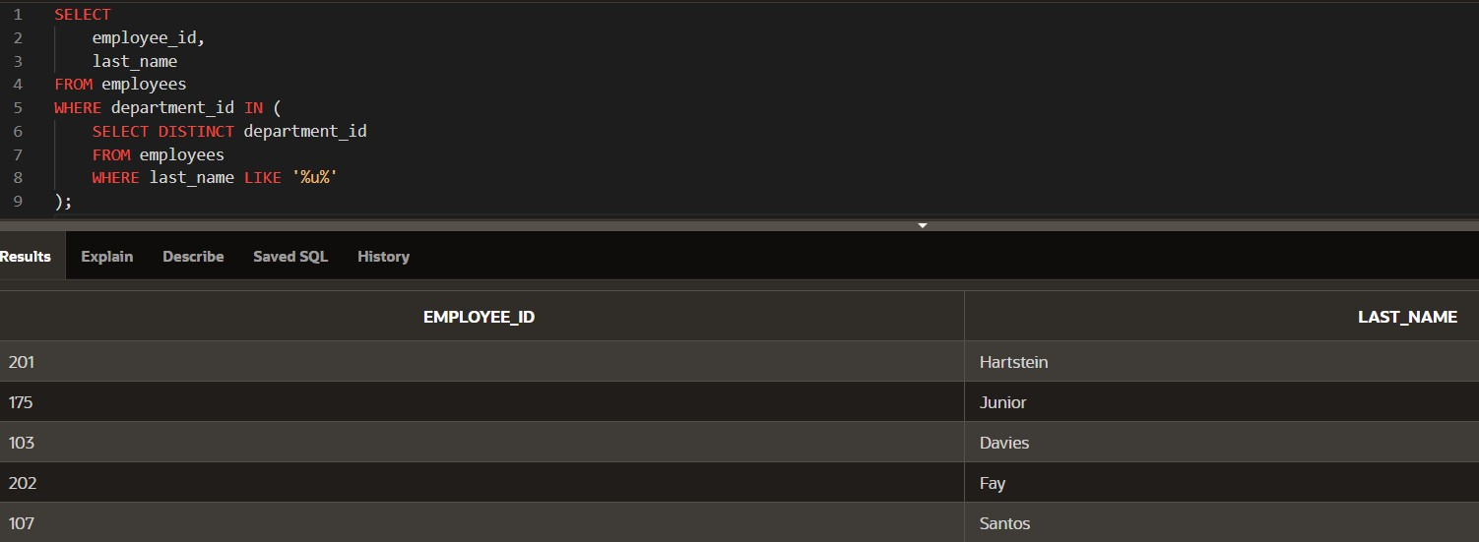

- The HR department needs a report that displays the last name, department number, and job ID of all employees whose department location ID is 1700.
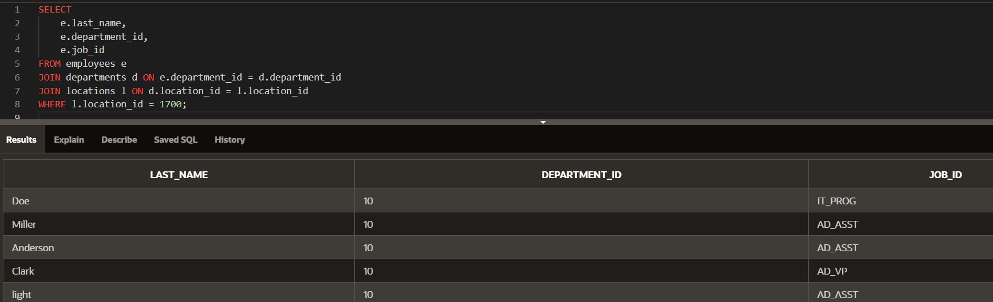

- Create a report for HR that displays the last name and salary of every employee who reports to King.
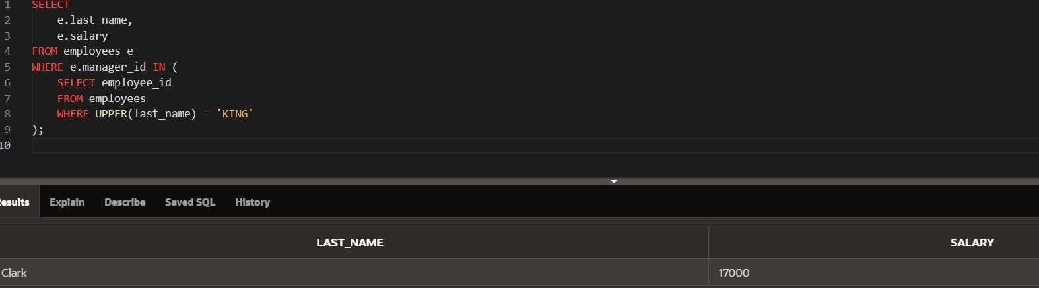

- Create a report for HR that displays the department number, last name, and job ID for
every employee in the Executive department.
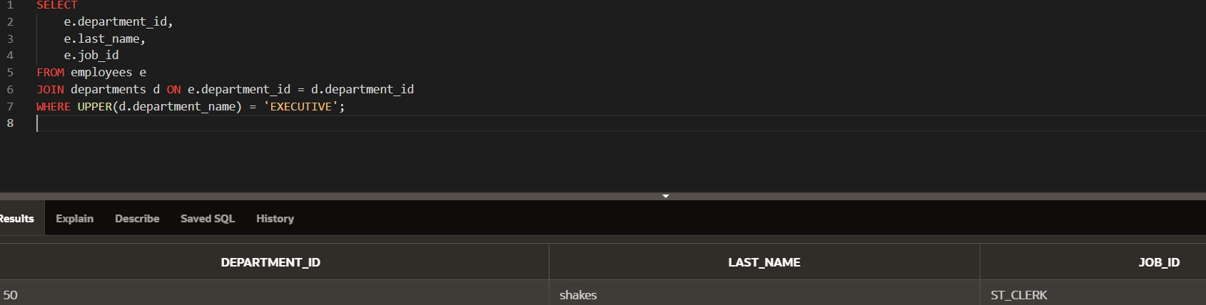

- Modify the query 3 to display the employee number, last name, and salary of all employees who earn more than the average salary and who work in a department with any employee whose last name contains a u.
